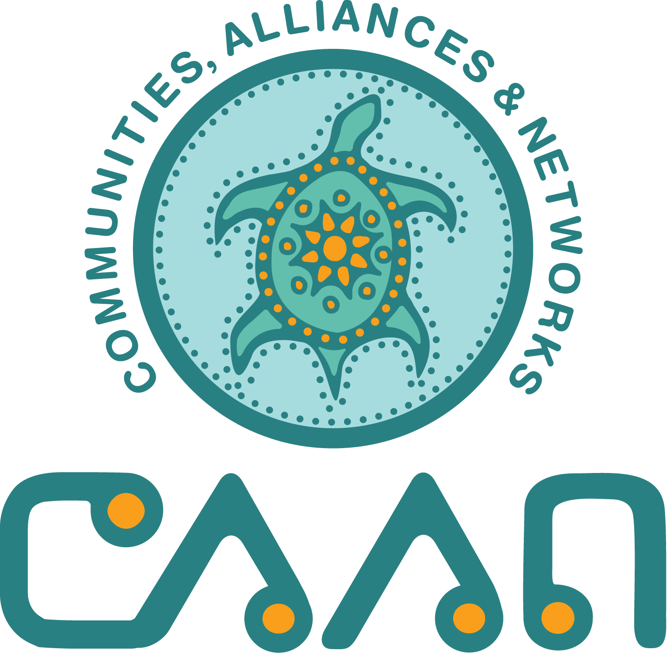
CAAN and the AHA Centre present
Wise Practices and Skills Building Gathering
May 18 – 20, 2022
Theme: Capacity Bridging
Location: Hotel Fairmont Winnipeg
2 Lombard Place, Winnipeg, MB R3B 0Y3

ABSTRACT DEADLINE: February 14, 2022

Please e-mail completed application to: patrickb@caan.ca

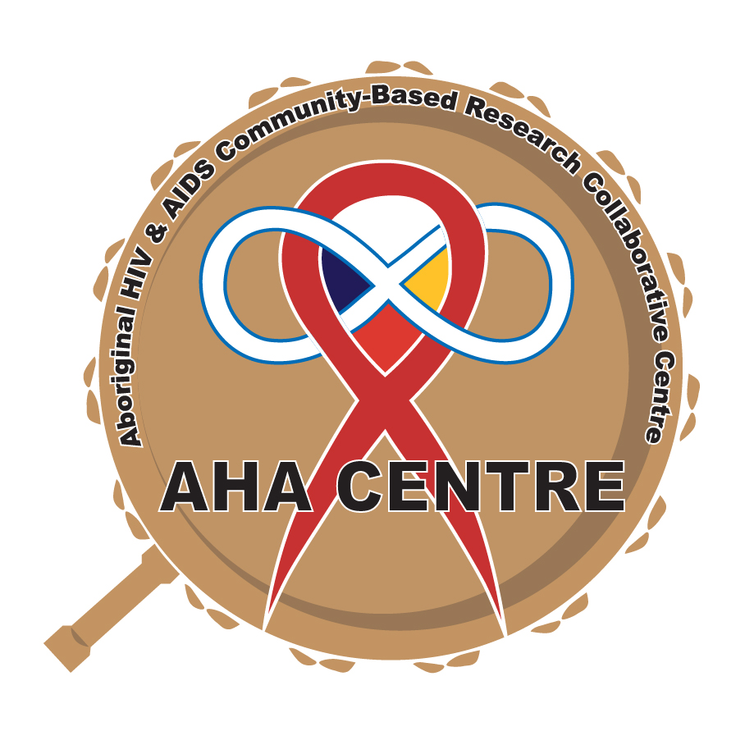

GATHERING GOAL: To bring together members of the Indigenous HIV, HCV and STBBI community to discuss, share and model wise practices that are grounded in community programming and community-based research (CBR), and that embody the living and lived experiences of Indigenous Peoples and HIV, HCV and STBBI.

GATHERING OBJECTIVES:
- To increase uptake and application of research findings in policy, programming and practice.
- To share program-related initiatives.
- To increase the number of community-based researchers with knowledge of Indigenous CBR design and data analysis available to conduct HIV and AIDS and/or HCV and STBBI research in Indigenous communities.
- To increase opportunities for knowledge sharing and the scale-up of effective programming in response to issues related to Indigenous Peoples and HIV, HCV and/or STBBI.

Submitting authors must indicate the stream(s) that their abstract best suits.
Depending on the abstracts received, your presentation may be assigned to a different stream as availability allows.

Preference will be given to abstracts about HIV and AIDS, HCV and/or STBBI programming and research by First Nations, Inuit and Métis that:
- emphasize self-determination;
- embed Indigenous Ways of Knowing and Doing (IWKD) and;
- are written from a strengths-based perspective.

Knowledge Sharing Streams:
Abstracts
Wholistic Programming, Interventions and Health Practices for People living with HIV, HCV and STBBI

Workshops may include culturally responsive prevention and support interventions and/or programming for Indigenous People living with HIV, HCV, and STBBI; highlight the Indigenous response to HIV, HEP C, STBBI including training, toolkits, knowledge exchange, storytelling and evaluation, for example. Workshops that offer self-care, traditional arts and/or crafts, for example will be considered.

Sharing what we’ve learned from Community-Based Research (CBR)

Presentations focus on research results and findings, lessons learned and recommendations. New and innovative research methods, outcomes, and processes; stories of community-based research that created change; examples of ethical issues or questions in community-based research etc.

I want to do Community-Based Research—what do I need to know?

This workshop stream focuses on the who, what, how and whys of community-based research (CBR). Do you and your research team have innovative ideas for data collection, community engagement, participatory analysis or any other part of the research process that you’d like to share? Workshops could range from topics like CBR 101 to innovative knowledge translation activities. Your session could be aimed at any and/or all members of the research community.

Please indicate which stream(s) you think best describes your work using the descriptions provided in the table above:
☐Wholistic Programming, Interventions and Health Practices for People living with HIV, HCV and STBBI
☐Sharing what we’ve learned from Community-Based Research (CBR)
☐Lived and Living Experience
☐I want to do Community-Based Research—what do I need to know?

Please indicate if you would prefer an oral presentation or a workshop spot.
☐Oral presentation (15-minute presentation/5-minute question period)
☐Workshop (interactive learning session)
☐60 minutes
☐70 minutes
☐90 minutes

Will you and your team be attending Wise Practices 2022 in person or virtually?
☐In person
☐Virtually
☐Not sure

Please note:
Due to limited funds, CAAN is unable to provide travel assistance for presenters to attend the Skills Building or Wise Practices sessions in 2022. All travel and related expenses are the responsibility of the presenter, should their abstract be approved.

Registration fees for main contact / presenting authors will be waived.
PRESENTERS/AUTHOR(S) (please print clearly)
All information is mandatory for your submission to be considered.

Information for the main contact — Presenting Author:

All presenters must submit a short bio (no more than 120 words) in a separate Word Document.

Name: ______________________________________________________________

Affiliation: ______________________________________________________________

Address: ______________________________________________________________

City: _______________________ Prov/Terr: ______ Postal Code: ______

Email: ______________________________________________________

Please include the name and affiliation of any additional presenters/authors, communities, or organizations contributing to the work and provide bios for these presenters. By listing co-presenters, you are confirming that each person has reviewed and agreed to the abstract as presented here.

Name: ____________________________ Affiliation: ____________________________

Name: ____________________________ Affiliation: ____________________________

Name ____________________________ Affiliation ________________________________

Name ____________________________ Affiliation ________________________________

Please check which audio or visual equipment you will need for your session. Note: this applies to in-person sessions in Winnipeg only.

☐Flipchart and markers
☐Speakers
☐Microphone
☐Other: ____________________________________________

ABSTRACTS:
Please provide a detailed description of the presentation.
NOTE: Abstracts should be no more than 300 words and should be organized according to the structure outlined below. No section may be left blank.

Title: title of presentation or workshop

Plain language summary: gives an overview of your project in plain language. Please note: this text will be used as your abstract in the program;

Workshop format: description of how your workshop will be conducted. NOTE: this does not apply to 15-minute oral presentations.

Background/Issue: a description of the project, program, or experience;

Processes/Methods: description of community and/or participants, research process, measures, evaluation and analysis procedures;

Learnings: highlight the results or expected outcomes of the work; and

Conclusion(s): describe the outcomes, limitations, recommendations, and/or potential implications for your project.

NOTIFICATION OF ACCEPTANCE
Presenting authors will be notified of the status of their submission by email in late February or early March, 2022.

If you have any questions, please contact Patrick Brownlee at the CAAN Research Unit:

E-mail: patrickb@caan.ca Tel: (306) 432-5279

Check List

Please ensure that you have included the following with your submission package:
☐Indicated whether you’re applying for an oral presentation or a workshop?
☐Indicated which stream you are applying to?
☐Listed your co-presenters?
☐Provided 120 word biography for ALL presenters?
☐Included a 250 word abstract outlining your workshop or oral presentation?
☐Indicated whether you will be attending in person or virtually?

