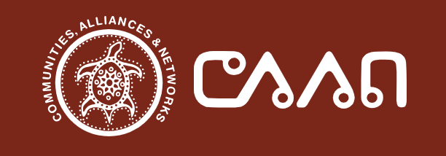
Strategic Plan

To be initiated in 2024 and refreshed annually.

Submitted by: Johnston Research Inc. Date: March 2024

Table of Contents
Table of Contents 2
Acknowledgements 3
Board of Directors 3
Preface by the CEO (okimaw) 4
Description of the Organization 5
Executive Summary 6
Introduction 7
Core Values 8
Vision 8
Mission 9
Strategic Priorities and Related Strategies 10
Strategic Priority #1: Resources and Operations 11
Strategic Priority #2: Addressing Lateral Violence 14
Strategic Priority #3: Decision-making with Agencies 15
Strategic Priority #4: Strengthening our Membership 16
Strategic Priority #5: Knowledge Sharing, Research, and Evaluation 17

Acknowledgements
CAAN Communities, Alliances & Networks (CAAN) is pleased to present the CAAN Strategic Plan, which will be initiated in 2024 and refreshed annually.
This multi-year strategy was made possible thanks to the input and contributions of many individuals and groups across Canada who care deeply about the health of First Nations, Inuit, and Métis Peoples. In addition, acknowledgements are made to the many delegates who participated in the February 14-15, 2024, CAAN-hosted Visioning Gathering, including CAAN Board members (both past and present), and Indigenous communities for their invaluable feedback. The great care, honesty, and openness taken in the articulation of strategic priorities were evidenced in the breadth and diversity of responses. As a result, several individuals and groups collaborated to produce a strategic plan that will be refreshed on an annual basis.
CAAN invites you to read this Strategic Plan to learn more about how CAAN plans to support and improve the health and well-being of all Indigenous Peoples impacted by HIV and AIDS, HCV, STBBIs, TB, mental health, aging, and related co-morbidity issues.

Board of Directors
CAAN’s Board of Directors come from across Canada, each bringing unique combinations of lived and living experience, wisdom, tradition and passion to the work. As of March 2024, the Board consists of the following people:
- Mathew Fluery, Chair of the Board
- Gayle Pruden, Vice-Chair of the Board
- Patti Tait, Secretary of the Board
- Jared BigCanoe, Treasurer of the Board
- Danita Wahpoosewyan, Board member
- Edward Wilson, Board member

Preface by the CEO (okimaw)

It is beautiful to be able to wake up to a new day. As a grandmother and an entity that lives and exists in this universe to help and guide us as we move forward, I am so happy today to be able to look at new beginnings and the new vision for CAAN Communities, Alliances & Networks (CAAN).
As we begin to move forward and acknowledge the people we serve back in our home fires, in our communities, in our nations and places of work and play (may we never forget that), we must acknowledge ourselves as human beings and make sure that we are taking care of ourselves in many different ways, mentally, emotionally, physically and spiritually. This includes standing among our ancestors who are present today, that have been asked to come and help us. Your ancestors that are coming through you bring words of life, that good life that we talk about.
Margaret Kisikaw Piyesis
okimaw, CAAN

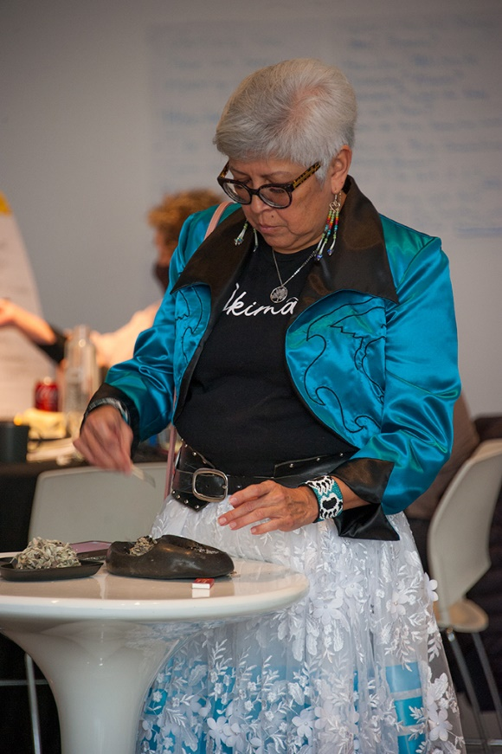
CAAN okimaw Margaret Kisikaw Piyesis, Day Two of the February 14-15, 2024 CAAN-hosted Visioning Gathering, Ottawa, Ontario.

Description of the Organization
CAAN initially stood for the Canadian Aboriginal AIDS Network. It is now known as CAAN Communities, Alliances & Networks (CAAN).
CAAN has over two decades of history as an incorporated non-profit organization whose HIV and AIDS focused mandate now:
- Provides a national forum to address HIV and AIDS, HCV, STBBI, TB, mental health, aging, and related co-morbidity issues.
- Promotes a social determinants of health framework through advocacy and committing to youth, and early intervention/prevention efforts.
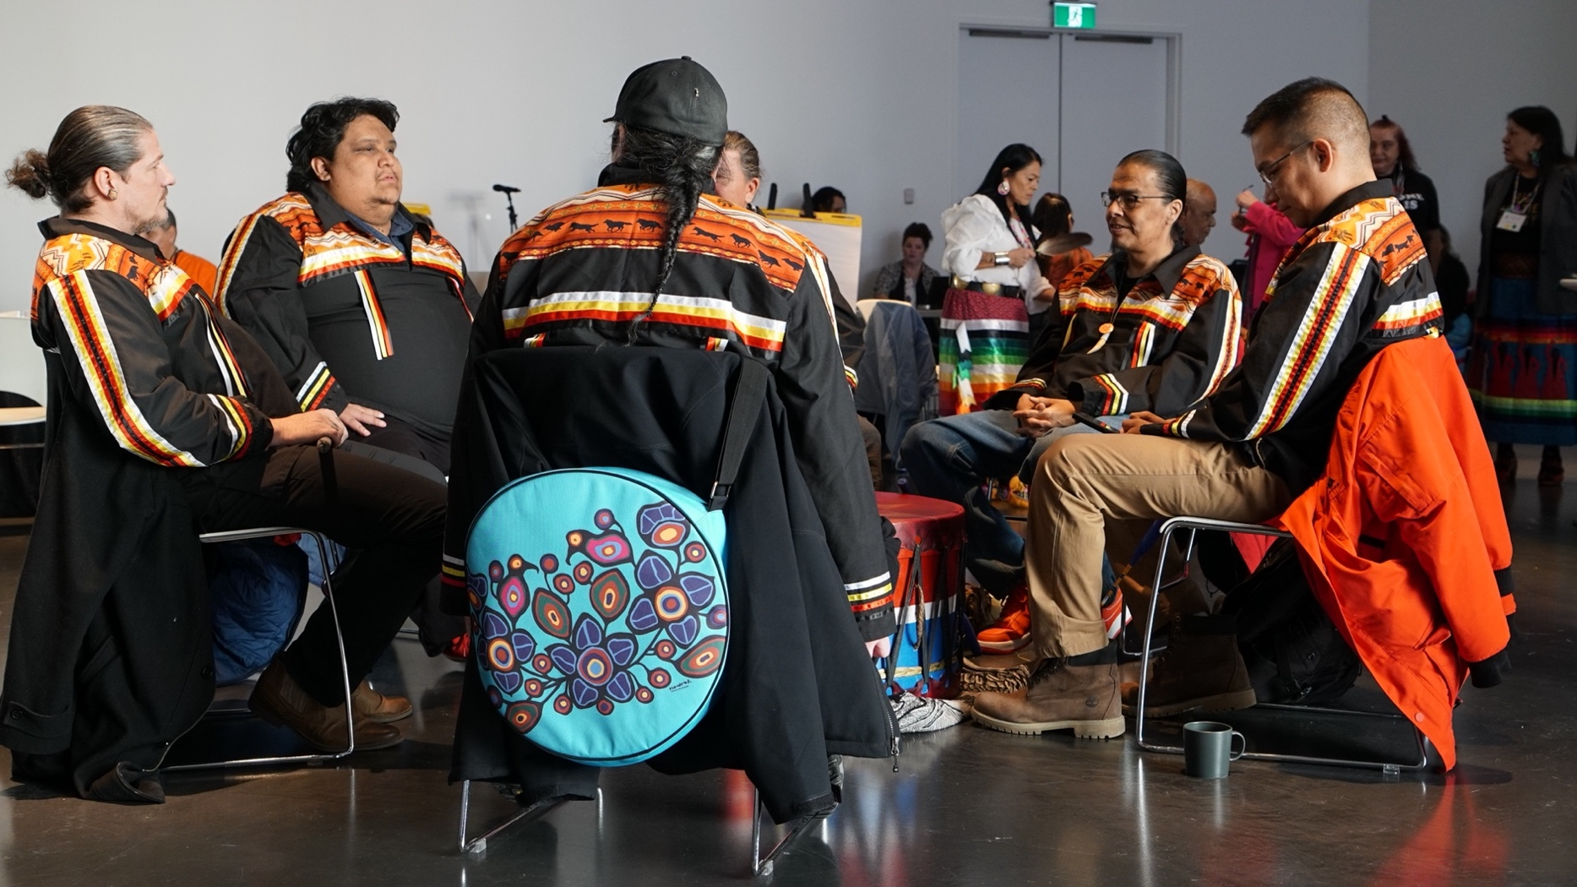
- Provides accurate and up-to-date resources on these issues in a culturally relevant manner for Indigenous Peoples wherever they reside (regionally, nationally or globally).
SpiritWolf Singers, Day One of the February 14-15, 2024 CAAN-hosted Visioning Gathering, Ottawa, Ontario.

Executive Summary

In 2024, CAAN Communities, Alliances & Networks (CAAN) began a strategic planning process initiated at a national visioning gathering in Ottawa on February 14-15, 2024, involving over 75 delegates who participated in person and virtually.

The vision of CAAN is an organization that lives by the fundamentals of Indigenous thought and worldviews, including the prioritization of land, language, Elders and youth, and 2-Spirit individuals; remaining meaningfully connected with its grassroots membership base in a way that effectively supports the membership in its direction and leadership.

The mission of CAAN is to provide a national forum to address HIV and AIDS, HCV, STBBI, TB, mental health, aging and related co-morbidity issues in a culturally relevant manner with and for Indigenous Peoples.
CAAN has five strategic priorities noted as follows:
- Resources and Operations
- Addressing Lateral Violence
- Decision-making with Agencies
- Strengthening our Membership
- Knowledge Sharing, Research and Evaluation

These strategic priorities as outlined in this strategic plan are accompanied by philosophy statements, strategies, critical success factors, and implementation and measurement activities.

Introduction

On February 14-15, 2024, in Ottawa, over 75 delegates participated in a Visioning Gathering hosted by CAAN Communities, Alliances & Networks (CAAN). This gathering was a ceremony involving singing, drumming, and dancing, and where many of the delegates wore their traditional regalia. At this event, everyone took part in a strategic planning process, which included reviewing challenges and opportunities and brainstorming solutions to support CAAN in achieving its mandate.

CAAN’s vision of a grassroots organization that lives by the fundamentals of Indigenous thought and worldviews to support the health and well-being of all Indigenous Peoples is supported by its mission. The mission is for CAAN to provide a national forum to address HIV and AIDS, HCV, STBBI, TB, mental health, aging and related co-morbidity issues in a culturally relevant manner with and for Indigenous Peoples. This requires CAAN to build capacity across Indigenous leaders, organizations and communities, and others, which are formed through strong trusting relationships. Capacity and relationship building will be realized by CAAN through meaningful and significant partnerships that honour Indigenous Peoples’ right to self-determination.

CAAN’s program planning, research and action plans will be based on the philosophy statements, strategies, critical success factors, and implementation and measurement activities as outlined in this strategic plan.

Core Values

The CAAN vision and mission ensures our actions build meaningful and significant partnerships that honour Indigenous Peoples and their right to self-determination, Indigenous languages, honour our ancestors, and look towards the future of our youth.

We therefore focus on:

  - Respect for the autonomy of Indigenous communities and nations to self-determine their knowledge and research needs, their path, and their futures.

  - Fair, transparent and accountable processes for decision-making and action.

  - Build equitable partnerships with Indigenous Peoples, communities and organizations.

  - Build capacity within the CAAN system for supporting health, addressing HIV and AIDS, HCV, STBBI, TB, mental health, aging and related co-morbidity issues in a culturally relevant manner.

Vision

CAAN Communities, Alliances & Networks that lives by the fundamentals of Indigenous thought and worldviews, including the prioritization of land, language, Elders and youth, and 2-Spirit individuals; remaining meaningfully connected with its grassroots membership base in a way that effectively supports the membership in its direction and leadership.

Mission

CAAN’s mission is to provide a national forum to address HIV and AIDS, as well as HCV, STBBI, TB, mental health, aging and other related co-morbidity issues in a culturally relevant manner with and for Indigenous Peoples.
CAAN aims to accomplish its mission through:
- Providing accurate and up-to-date information (including relevant, current research) about HIV in Indigenous communities, STBBI and the various modes of transmission As well as, mental health and other social determinants of health.
- Providing opportunities for leaders, advocates and individuals in the HIV/AIDS movement a chance to share their issues on a national level by building skills, education/awareness campaigns, and acting in support of harm reduction techniques.
- Facilitating the creation and development of regional Indigenous HIV/AIDS service agencies through leadership, advocacy and support.
- Designing material which are Indigenous specific for education and awareness at a national level, and to lessen resource costs of underfunded, regional agencies by distributing and making available these materials wherever possible.
- Advocating on behalf of Indigenous Peoples living with HIV and AIDS (IPHAs), HCV, STBBI, TB, mental health, aging, and related co-morbidity issues by giving them forums in which to share their experiences, and providing opportunities for meaningful engagement within CAAN.
- Facilitating the development of healing and wholeness strategies among the Indigenous population.
- Building partnerships with Indigenous and non-Indigenous agencies which address the issues of Indigenous Peoples across jurisdictions, thereby improving the conditions in which Indigenous Peoples in Canada live through a continuous and focused effort.

Strategic Priorities and Related Strategies

This strategic plan outlines five strategic priorities that focus on:
- Resources and Operations
- Addressing Lateral Violence
- Decision-making with Agencies
- Strengthening our Membership
- Knowledge Sharing, Research and Evaluation

Each of these strategic priorities are accompanied by related strategies, critical success factors, and implementation and measurement activities.

The strategic planning process started at the February 14-15, 2024 CAAN-hosted Visioning Gathering. Here it was determined that there is an overarching need for the CAAN Communities, Alliances & Networks to reconnect with, and exemplify the fundamentals of Indigenous thought and worldviews, including the prioritization of land, language, Elders and youth, and 2-Spirit individuals through its work. This work was instrumental in conceptualizing the critical success factors, and how to support implementation. Although the success factors and implementation plans may vary among the strategic priorities, common thread of capacity building (among Elders and youth in creating training platforms and opportunities), self-determination (in asserting needs, and driving meaningful community-based research) and knowledge sharing (supporting knowledge mobilization activities that are accessible to communities) are woven throughout.

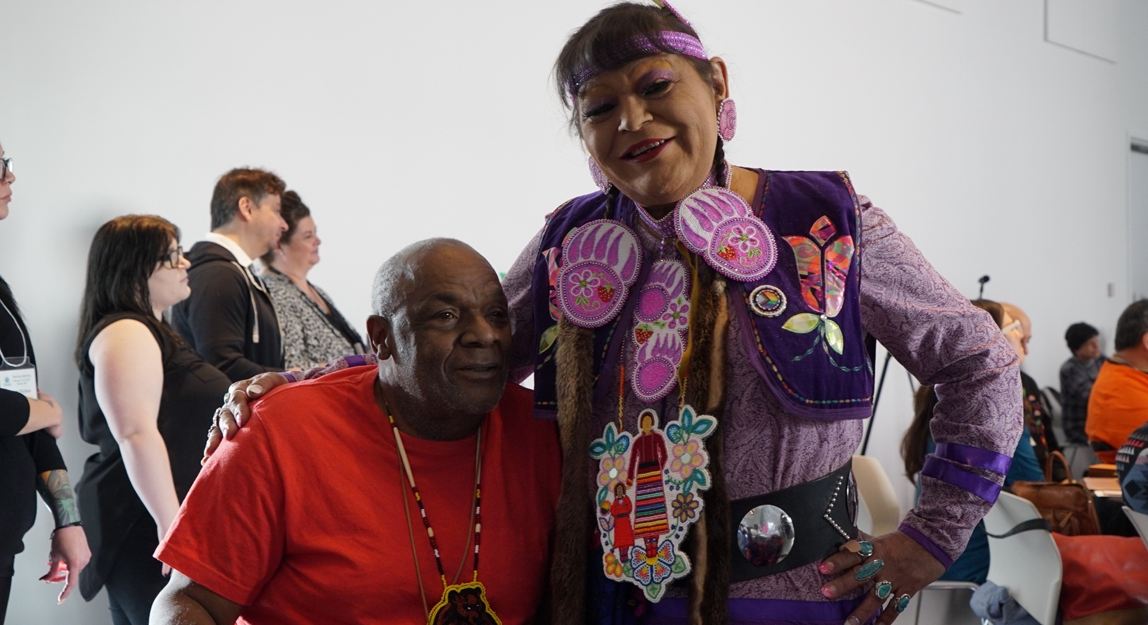
Past CAAN Board Member Donald Turner, and CAAN Vice-Chair of the Board Gayle Pruden, Day One of the February 14-15, 2024 CAAN-hosted Visioning Gathering, Ottawa, Ontario.

Strategic Priority #1: Resources and Operations

Philosophy: building and developing relationships that support CAAN’s core values, vision and mission, including mentoring the next generation.
Strategies (1-2 years to initiate)
- Review the CAAN Strategic Plan annually.
- Incorporate innovative approaches to support human resources and engage Elders, youth and other key groups such as:
  - Requiring youth representation on the Board.
  - Establishing youth council that is separate from the board and warrior societies to provide job/volunteer experience and skills in governance.
  - Inclusion and on-going recruitment of members to the warrior societies (IPHA, Indigenous people living with Hepatitis C, and Voices of Women) that convene separately, and report to the Board and/or senior management.
- Recruit and retain qualified staff to work at CAAN and implement professional development opportunities such as Indigenous leadership institutes.
- Provide mentorship opportunities that pair experienced staff with newer employees to advance transfer knowledge and build relationships within the organization.
- Provide continuing education opportunities on various STBBIs and TB to ensure all staff have current knowledge on the infectious diseases they address in their populations.
- Build diverse relationships with funding organizations and partners at all levels; local, regional, national and international.
- Review of CAAN’s position with respect to the national and global initiatives (e.g., Canadian STBBI Action Plan; 95-95-95 HIV goals for 2025; ending AIDS as a public health threat by 2030; and the United Nations General Assembly political declarations on TB, HIV and pandemic preparedness).
- Ensure processes are agile and adaptable to changing priorities, community needs and new technologies.
- Ensure that processes are inclusive and participator; involving staff and community members in decision-making processes to ensure that changes reflect their needs and priorities.
- Ensure that quality assurance within CAAN includes conducting risk assessments, business line reviews, financial assessments, etc.

Critical Success Factors:
- Meaningful engagement with membership, especially with Elders and youth.
- Professional development opportunities for staff.

Implementation and Measurement Activities
As an internal review process, monitor and evaluate the implementation of the strategic plan through conducting regular surveys on program effectiveness, successes and challenges, and the evaluation of finances. Ensure that all review, research and evaluation efforts are validated by communities, partners, stakeholders and staff.

Specifically, through measuring:
- Number and quality of engagements with Elders and youth.
- Assessment of risk, control and accountability at CAAN.
- Staff retention rates.
- Staff satisfaction scores, including qualitative evidence of satisfaction levels.

Strategic Priority #2: Addressing Lateral Violence

Philosophy: supporting all levels of CAAN from the leadership circle and staff to membership in understanding the effects of and addressing lateral violence.

Strategies (1-2 years to initiate)
- Providing training on lateral violence and its effects that are specific to leadership, staff and volunteers.
- Providing culturally relevant resource material on lateral violence to membership, ensuring materials are accessible to all members.
- Creating and implementing standard codes of conduct that addresses lateral violence, in collaboration with staff and membership to ensure buy-in and adherence.

Critical Success Factors
- Tangible, positive changes to overall workplace safety and culture.
- Improvement of staff and leadership retention.
- Improvements in relationships, communication, and collaboration among staff and leadership.
- Promotion of social harmony and healthy relationships among leadership, staff and membership; ensuring that staff can build successful working relationships free of bullying, gossip, alienation or demeaning actions.

Implementation and Measurement Activities
As an internal review process, monitor and evaluate the implementation of the CAAN Strategic Plan through conducting regular surveys on training effectiveness, successes and challenges.

Specifically, through measuring:
- Staff retention rates.
- Staff satisfaction scores and qualitative evidence of healthy workplace relationships.
- Number and utility of training sessions conducted (qualitative or quantitative).

Strategic Priority #3: Decision-making with Agencies
Philosophy: collaboratively make decisions based on evidence with an arms-length independent body (i.e., senate) whose own mandate is to support and advise CAAN.
Strategies (1-2 years to initiate)
- Providing transparency on Board policies, by-laws and constitutions and voting rights.
  - Ensure that the information is presented in a way that is easily understood by all membership, regardless of their level of familiarity with governance structures
- Support and incorporate innovative approaches to service delivery and partnership for member organizations.

Critical Success Factors
- Board policies are easily understood by membership.

Implementation and Measurement Activities
As an internal review process, monitor and evaluate the implementation of the strategic plan through conducting regular surveys on program effectiveness, successes and challenges, and partnerships. Ensure that all review processes and research are validated by the communities.

Specifically, through measuring:
- Level of satisfaction with partnerships from both the CAAN and partner perspectives.
- Level of understanding of board policies and procedures.
- Assessment of program effectiveness, successes and challenges (qualitative or quantitative).
- Impact of these policies on decision-making processes and outcomes.

Strategic Priority #4: Strengthening our Membership

Philosophy: be membership driven and strengthen trust while ensuring that lived experience is centered, there is GIPA and MEPA, and exemplifying the notion of “nothing about us without us.”

Strategies (1-2 years to initiate)
- Ensure that the principles of GIPA (Greater Involvement of People Living with HIV and/or AIDS) and MEPA (Meaningful Engagement of People Living with HIV and/or AIDS) are practiced.
- Increase participation and engagement with Elders and youth (as chosen/determined by membership).
  - Improve youth engagement with a youth-specific mentorship program, youth council, creating roles for content creation, ambassadors, etc.
- Broaden culture outreach to include Inuit and Métis Peoples and ensure diversity and inclusion in membership to also include northern and remote communities.

“Elders hold a very good place in the organization, and engagement is crucial to the livelihood of the organization.” (Visioning Gathering participant, 2024)

Critical Success Factors
- Implemented guidelines for application / membership that are co-created with membership to ensure they reflect needs and values of the community.
- Guidelines are transparent, easily accessible, and inclusive.

Implementation and Measurement Activities
As an internal review process, monitor and evaluate the implementation of the CAAN Strategic Plan through conducting both quantitative assessments such as regular surveys, and qualitative assessment like focus groups/interviews on membership needs and priorities. Ensure that all review processes and research are validated by the membership.

Specifically, through measuring:
- Number and quality of engagements with Elders and youth.
- Assessment of mentorship programs focusing on successes, challenges, barriers, areas of improvement, etc.
- Assessment of outreach effectiveness targeting Inuit and Métis Peoples, remote communities, etc.
- Assessment of level of trust within the CAAN membership.
- Level of satisfaction with communications, and opportunities to provide feedback.

Strategic Priority #5: Knowledge Sharing, Research, and Evaluation

Philosophy: strategic partnerships in research, evaluation, and knowledge sharing advance CAAN’s ability to fulfill its mission and reflect the needs and wishes of communities served.

Strategies (1-2 years to initiate)
- Increase awareness and national advocacy of CAAN with agencies and individuals across all social determinants of health but, also in providing targeted information and guidance on HIV and Hepatitis C to grassroots communities.
- Identify, and be open to different ways of conducting evaluation (e.g., sharing circles, storyboards, storytelling) to ensure that safe spaces are created for Indigenous Peoples to share their stories.
- Learn from other countries and communities across Canada (e.g., cultural exchange program, summits, seasonal gatherings to bring people together from diverse backgrounds).
- Direct and manage research projects (e.g., identify resources for investigating funding opportunities and critically analyzing the criteria).
- Work at the street levels, and with those who are disenfranchised (e.g., straight men living with HIV, sex workers) to improve knowledge mobilization.
- Centralized hub for resources, including but not limited to interactive maps, and online service information to reduce barriers to access.
- Advocate for an Indigenous-led health research institute that focuses on data preservation and sovereignty with CAAN that focuses on HIV, Hepatitis C, and any other relevant research as determined.
- Continue to review and enhance the research portfolio to ensure it reflects both internal research needs and current community needs; with consideration for how to identify funders that will support membership-driven research initiatives.

Critical Success Factors
- The number of, and quality of partnerships at all levels.
- Assessment of program impacts, successes and challenges.
- Research efforts are community driven, in that it is validated and/or determined by the communities served, and is used to have an impact.

Implementation and Measurement Activities
As an internal review process, monitor and evaluate the implementation of the CAAN Strategic Plan through conducting regular surveys on program effectiveness, successes and challenges, and partnerships. Collaborate with Indigenous researchers and community members to co-create evaluation methods that reflect the needs and values of the community.

Specifically, through measuring:
- Number and quality of partnerships.
- Assessment of programs (e.g., successes, challenges, barriers, areas of improvement).
- Assessment of outreach effectiveness with various groups (e.g., grassroots communities, international partners).
- Assessment of effectiveness and use of research.
- Assessment of the impact of advocacy efforts and research on policy and practice. Specifically, in number and quality of partnerships, as well as the effectiveness and use of research in informing decision-making.

